  Before reading | R.1
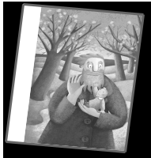

Look at the title and the pictures. What do you think? Read and tick (✓).

The Selfish Giant

by Oscar Wilde

1 Which characters are in the story?
a monster | a giant | a witch
a bird | a duck | an owl
school children | animals | pets
a little boy | a little girl | a baby

2 | Where does the story happen?
 | in a park | in a garden | at school
3 | When does it happen?
 | in spring | in summer
 | in autumn | in winter
4 | The ending is …
 | happy | sad | happy and sad

- Think of a story you know with a giant. Write words and phrases to describe the giant.


© Cambridge University Press and Helbling Languages 2014 MORE! 8e The Selfish Giant PHOTOCOPIABLE

Jumbled story | R.2


- The Giant sees some children in his garden. They are sitting in the trees.

- Now there are flowers in the tree in the corner and the birds are singing. The little boy kisses the Giant.

- Every day some children play in a beautiful garden. It’s the Giant’s garden.

- The children are sad that they can’t play in the garden.

- But in one corner of the garden it’s winter. There’s a little boy and he can’t climb the tree.

- That afternoon the children find the Giant under the tree. He’s dead.

- One day the Giant comes back from holiday. He sees the children in his garden.

- One day the Giant hears a bird in his garden. It’s singing. He looks out of the window.

- The children play in the Giant’s garden every day for years and years, but the Giant never sees the little boy again.

- He’s angry that the children are in his garden. He tells them to go away.

- One winter morning the old Giant sees the little boy in his garden. He goes to him.

- The Giant goes into the garden, he picks up the boy and he puts him in the tree.

- The Giant tells all the children that they can play in his garden. They are all happy. But the Giant is sad that he can’t see the little boy.

- The trees are happy because the children are there again. The birds are singing and there are lots of flowers.

- It’s always winter and there are no flowers or birds in the Giant’s garden. The Giant doesn’t understand why.


© Cambridge University Press and Helbling Languages 2014 MORE! 8e The Selfish Giant PHOTOCOPIABLE

Character file

The Giant

Three questions

Where does he live?

Who does he live with?

How old is he …

- at the beginning of the story?

- at the end of the story?
R.3
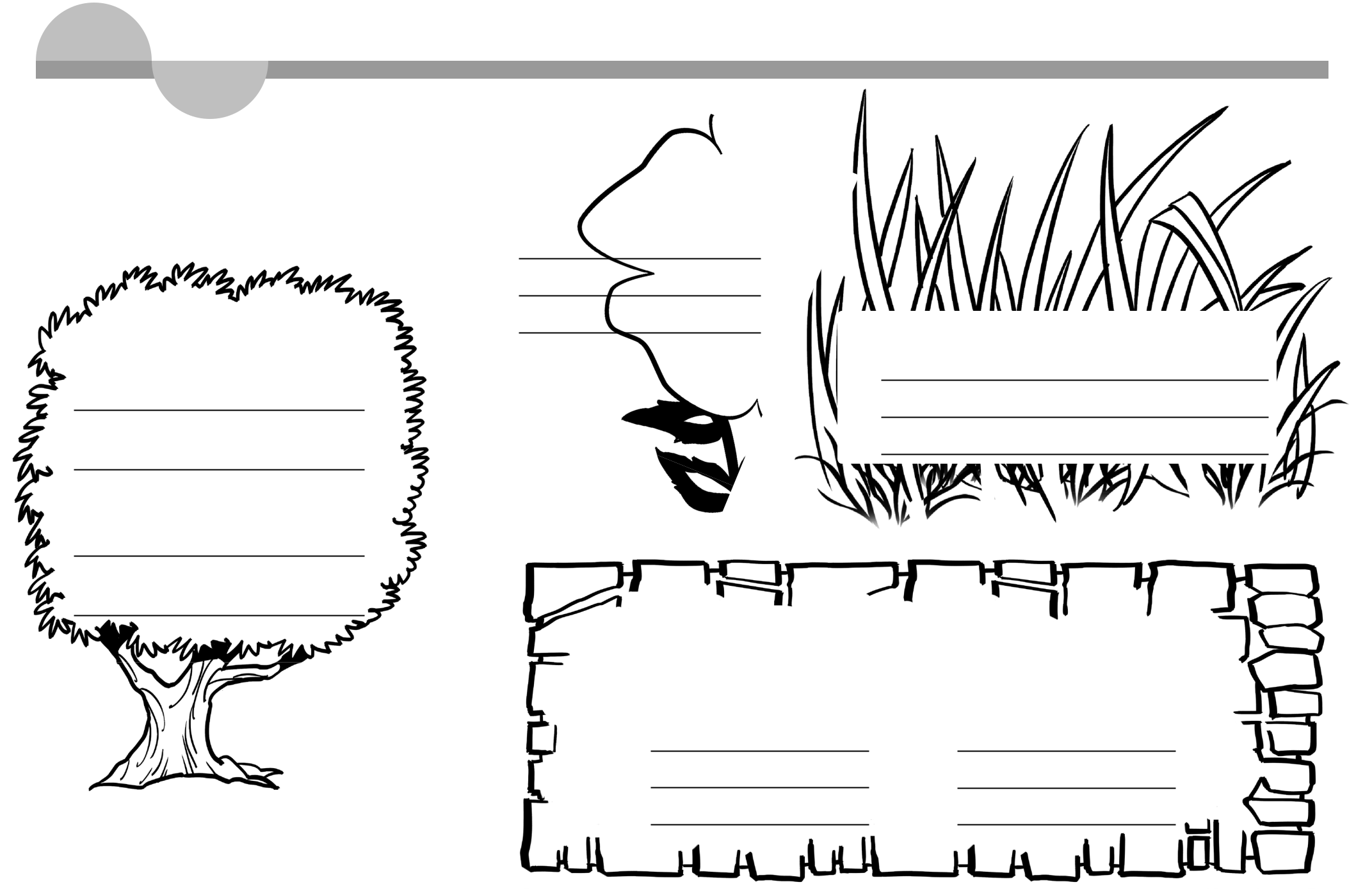

Three things he likes

1

2

3 | Three things he does in the story

1

2

3

Three adjectives

Write notes about the giant …

at the beginning | in the middle
1 | 1
2 | 2
3 | 3

© Cambridge University Press and Helbling Languages 2014 MORE! 8e The Selfish Giant PHOTOCOPIABLE

