Name: ________________________ Class: ________________

1. POPUNI TEKST PONUĐENIM RIJEČIMA:

February hours days months
30 day days season

A year has got 12 ____________________. Some months have got _________ _______________________ and some 31 days. ________________________ has got 28 day. There are 4 months in each __________________. Each week has got 7 _____________________. There are 24 _______________________ in a ______________________.

2. UPIŠI SLOVA KOJA NEDOSTAJU U NAZIVIMA MJESECI:

1. J _ N _ A _ _ 7. J _ L _
2. F E _ R U _ _ Y 8. A U _ U S _
3. M _ R C _ 9. S E _ _ E M _ _ R
4. A _ R _ L 10. O C _ O _ E _
5. M _ _ 11. N _ V _ M B _ _
6. J _ N _ 12. D E _ _ M _ E R

3. POREĐAJ SLOVA DA DOBIJEŠ NAZIVE DANA U NEDELJI A POTOM NAPIŠI REDNI BROJ DANA:

TUDESAY →_______________________ ___
MOANDY →_______________________ _1._
FIDRAY →_______________________ ___
WNEADDESY →_______________________ ___
TDHARSUY →_______________________ ___
STADAURY →_______________________ ___
SDAUNY →_______________________ ___

4. POPUNI SLOVA KOJA NEDOSTAJU U NAZIVIMA GODIŠNJIH DOBA I SPOJI IH SA SLIKAMA:

S _ M M _ _ A U _ U _ N W _ N _ E R S P _ I _ G

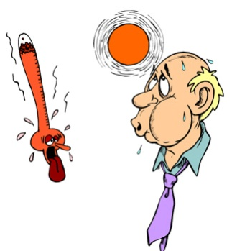

5. POREĐAJ RIJEČI,POČNI OD NAJKRAĆEG VREMENSKOG PERIODA PA SVE DO NAJDUŽEG:

MONTH SECOND HOUR SEASON

MINUTE WEEK YEAR DAY

1. _________________________
2. _________________________
3. _________________________
4. _________________________
5. _________________________
6. _________________________
7. _________________________
8. _________________________

